**Mawlana Bhashani Science and Technology University**



**Lab-Report**

Report No: 06

Course code: ICT-4202

Course title: Wireless and Mobile Communication Lab

Date of Performance: 25.09.2020

Date of Submission: 30.09.2020

**Submitted by Submitted To**

**Nazrul Islam**

Assistant Professor

Dept. of ICT

MBSTU.

**Name: Amrita kamkar**

**ID: IT-14060**

4th year 2ndsemester

Session: 2013-2014

Dept. of ICT

MBSTU.

**Experiment No: 06**

**Experiment name:** Switching an interface to move a host around a network using mininet.

**Objectives:** In this lab we are going to work with mininet to combine several networks in one. For this we need to install the mininet first.It can work in windows,linux,ubundu.

**Working Procedure After installation of mininet:** After installing the mininet, to check whether it is okay to work with we can write-

**Sudo mn**

Which gives the following output-

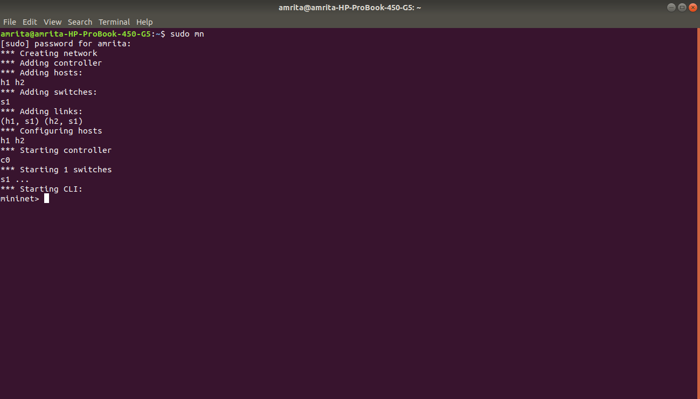

Another one is to create ping between two networks

**Sudo mn -- test pingall**

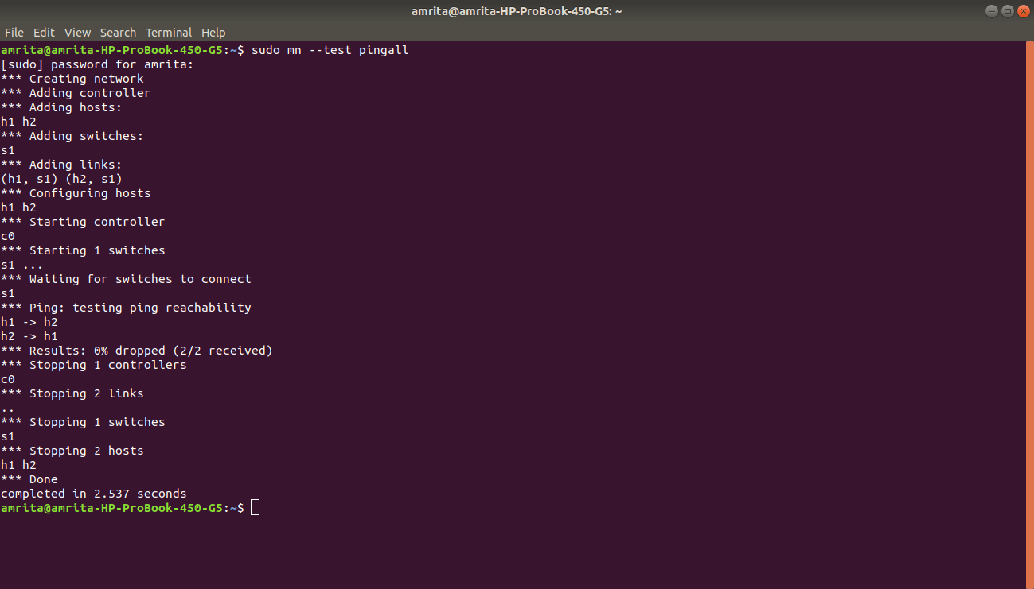

From these it’s clear mininet can work now.The source code we are going to use is-

**Pseudo code:**

from mininet.net import Mininet

from mininet.node import OVSSwitch

from mininet.topo import LinearTopo

from mininet.log import info, output, warn, setLogLevel

from random import randint

class MobilitySwitch( OVSSwitch ):

"Switch that can reattach and rename interfaces"

def delIntf( self, intf ):

"Remove (and detach) an interface"

port = self.ports[ intf ]

del self.ports[ intf ]

del self.intfs[ port ]

del self.nameToIntf[ intf.name ]

def addIntf( self, intf, rename=False, **kwargs ):

"Add (and reparent) an interface"

OVSSwitch.addIntf( self, intf, **kwargs )

intf.node = self

if rename:

self.renameIntf( intf )

def attach( self, intf ):

"Attach an interface and set its port"

port = self.ports[ intf ]

if port:

if self.isOldOVS():

self.cmd( 'ovs-vsctl add-port', self, intf )

else:

self.cmd( 'ovs-vsctl add-port', self, intf,

'-- set Interface', intf,

'ofport_request=%s' % port )

self.validatePort( intf )

def validatePort( self, intf ):

"Validate intf's OF port number"

ofport = int( self.cmd( 'ovs-vsctl get Interface', intf,

'ofport' ) )

if ofport != self.ports[ intf ]:

warn( 'WARNING: ofport for', intf, 'is actually', ofport,

'\n' )

def renameIntf( self, intf, newname='' ):

"Rename an interface (to its canonical name)"

intf.ifconfig( 'down' )

if not newname:

newname = '%s-eth%d' % ( self.name, self.ports[ intf ] )

intf.cmd( 'ip link set', intf, 'name', newname )

del self.nameToIntf[ intf.name ]

intf.name = newname

self.nameToIntf[ intf.name ] = intf

intf.ifconfig( 'up' )

def moveIntf( self, intf, switch, port=None, rename=True ):

"Move one of our interfaces to another switch"

self.detach( intf )

self.delIntf( intf )

switch.addIntf( intf, port=port, rename=rename )

switch.attach( intf )

def printConnections( switches ):

"Compactly print connected nodes to each switch"

for sw in switches:

output( '%s: ' % sw )

for intf in sw.intfList():

link = intf.link

if link:

intf1, intf2 = link.intf1, link.intf2

remote = intf1 if intf1.node != sw else intf2

output( '%s(%s) ' % ( remote.node, sw.ports[ intf ] ) )

output( '\n' )

def moveHost( host, oldSwitch, newSwitch, newPort=None ):

"Move a host from old switch to new switch"

hintf, sintf = host.connectionsTo( oldSwitch )[ 0 ]

oldSwitch.moveIntf( sintf, newSwitch, port=newPort )

return hintf, sintf

def mobilityTest():

"A simple test of mobility"

info( '* Simple mobility test\n' )

net = Mininet( topo=LinearTopo( 3 ), switch=MobilitySwitch )

info( '* Starting network:\n' )

net.start()

printConnections( net.switches )

info( '* Testing network\n' )

net.pingAll()

info( '* Identifying switch interface for h1\n' )

h1, old = net.get( 'h1', 's1' )

for s in 2, 3, 1:

new = net[ 's%d' % s ]

port = randint( 10, 20 )

info( '* Moving', h1, 'from', old, 'to', new, 'port', port, '\n' )

hintf, sintf = moveHost( h1, old, new, newPort=port )

info( '*', hintf, 'is now connected to', sintf, '\n' )

info( '* Clearing out old flows\n' )

for sw in net.switches:

sw.dpctl( 'del-flows' )

info( '* New network:\n' )

printConnections( net.switches )

info( '* Testing connectivity:\n' )

net.pingAll()

old = new

net.stop()

if __name__ == '__main__':

setLogLevel( 'info' )

mobilityTest()

These is a .py or python extension code which is in the example folder which is also under the mininet home folder. For this we need to change the directory so that the linux terminal get access of the code

**Cd mininet**

**Cd examples**

**Sudo ./mobility.py**

**The given output is**

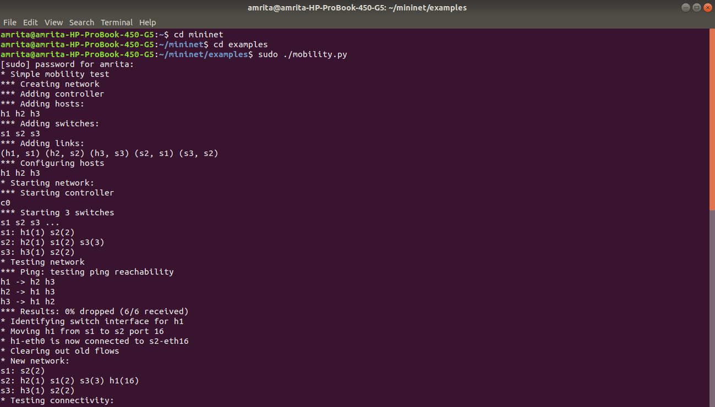

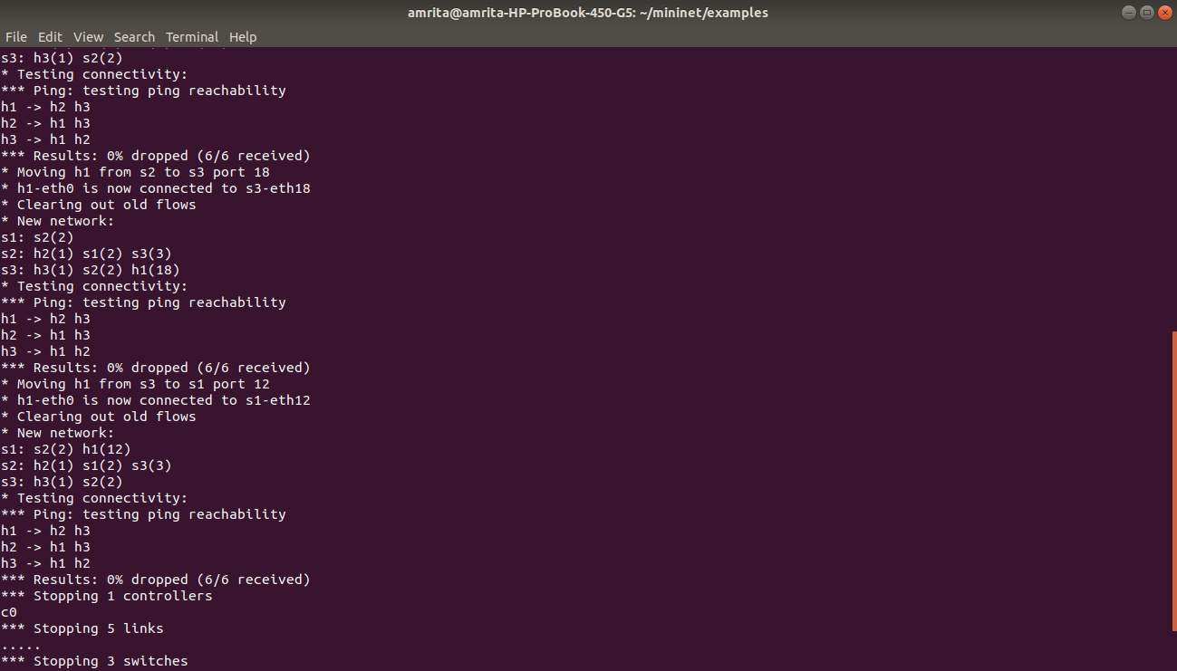

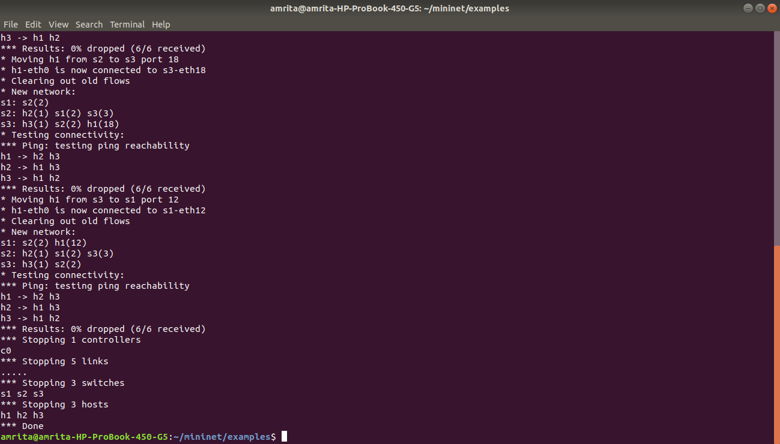

**Discussion:** In this lab, we learnt how to install the mininet and how does it work specially. The hosts were moving from each switches to another then come back to the first one which shows the absolute mobility test of networks running on mininet based on software.